**IN-Lab Task:**

**Question 01:**

**Using K-MAP, write down minimum SOP and actual expression. Implement Both actual and reduced expression on LogicWorks also create and verify Truth Tables of both Actual expression and minimum SOP of the following:**

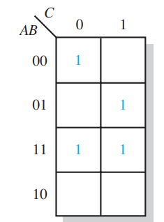

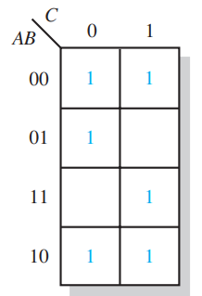

**POST-Lab Task:**

**Question 01:**

Make a POS Simplified Expression of the following. Note the Blank spaces represent 0.

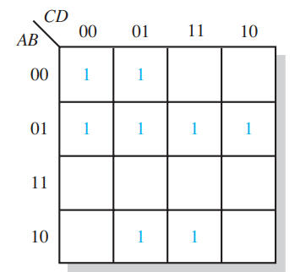

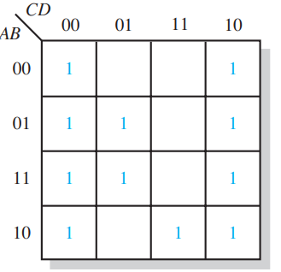

**Question: 2 Use K-MAP to minimize the given SOP expression. Implement the minimized SOP on LogicWorks and Complete Truth Table.**



**Question: 03 Use K-MAP to minimize the given SOP expression. Implement the minimized SOP on LogicWorks and Complete Truth Table. Also verify if POS expression can be made using the derived K-Map if yes Built one and its circuit on the software.**

